**Lesson Twenty-Five: The Last Week of the Life of Jesus – VII**

**The Third Stage of the Jewish Trial: Jesus Is Formally Condemned by the**

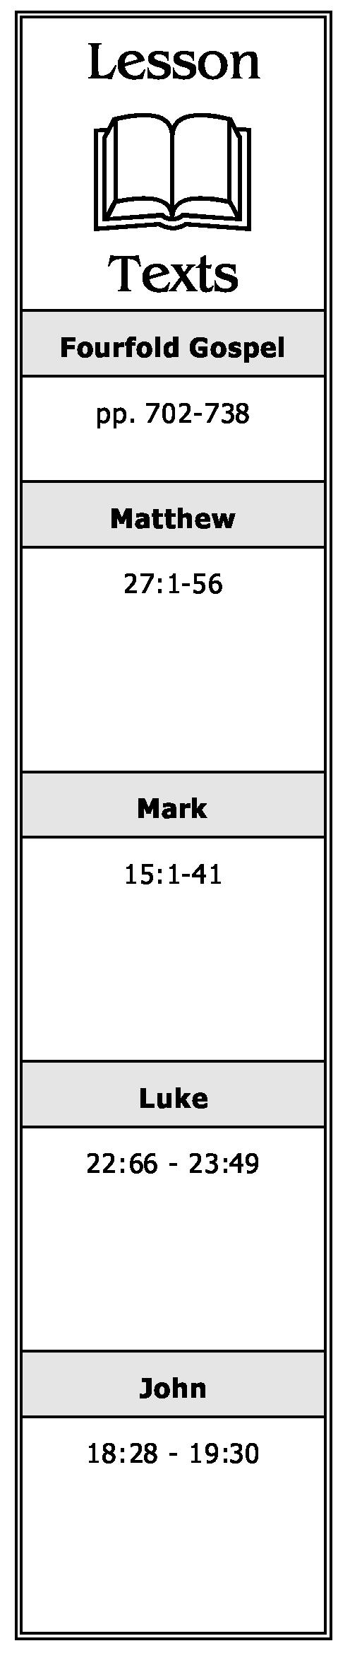

**Sanhedrin and Led to Pilate (Matthew 27:1-2; Mark 15:1; Luke 22:66 - 23:1;  
John 18:28)**

1. What final request do the chief priests, elders and scribes make of Jesus? What is His answer?
2. Upon hearing His response, what does the council do with Jesus? Why?

**The First Stage of the Roman Trial: Jesus Before Pilate for the First Time (Matthew 27:11-14; Mark 15:2-5; Luke 23:2-5; John 18:28-38)**

1. Where and to whom did the Jews take Jesus? Why did the Jews not enter into the place where they had taken Him?
2. What accusations did the Jews make against Jesus?
3. What question did Pilate ask of Jesus? What was His response?
4. What conclusion did Pilate reach concerning Jesus?

**The Second Stage of the Roman Trial: Jesus Before Herod Antipas (Luke 23:6-12)**

* 1. Why was Jesus sent to Herod? What was Herod’s reaction on seeing Him? Why?

What was Jesus’ reaction to Herod’s questioning? As a result, what did Herod and his men of war do with Jesus?

**The Third Stage of the Roman Trial: Pilate Reluctantly Sentences Jesus to Crucifixion (Matthew 27:15-30; Mark 15:6-19; Luke 23:13-25; John 18:39 - 19:16)**

1. What practice, in relation to prisoners, took place at the Passover?

**A Chronological Study of the Life of Jesus Gene Taylor 64**

1. Who was Barabbas?
2. What was the response of the mob when Pilate asked them if he should release Jesus?
3. What warning had Pilate’s wife given him concerning Jesus?
4. Even though Pilate had “washed his hands” of the matter, what did he allow to be done with Jesus?
5. What did the soldiers do to Jesus before they led Him away to be crucified?

**The Remorse and Suicide of Judas (Matthew 27:3-10; Acts 1:18-19)**

1. Upon seeing that Jesus was condemned to die, what did Judas do?
2. What was done with the money Judas had been given to betray Jesus?

**On the Way to the Cross (Matthew 27:31-34; Mark 15:20-23; Luke 23:26-33; John 19:17)**

1. Who was compelled to carry the cross of Jesus? Why?
2. Who followed Jesus as He made His way to Calvary? What did He say to them?
3. What happened when Jesus arrived at Golgotha?

**The Crucifixion (Matthew 27:35-56; Mark 15:24-41; Luke 23:33-49; John 19:18-30)**

1. What was done with the garments of Jesus?
2. At what hour of the day did the crucifixion begin? What sign was placed on the cross of Jesus?
3. What were the actions of those who passed by the cross of Jesus? The chief priests, scribes, and elders? The robbers who were being crucified with Him?
4. What did Jesus do when He saw Mary, His mother, standing by the cross?

**A Chronological Study of the Life of Jesus Gene Taylor 65**

1. What happened at the sixth hour?
2. What did Jesus do at the ninth hour? What was the reaction of the people to this?
3. What happened when Jesus died?
4. What conclusion did the centurion who had been in charge of the crucifixion reach?

**The Burial of Jesus (Matthew 27:57-66; Mark 15:42-47; Luke 23:50-56; John 19:31-42)**

1. How did the soldiers make sure the ones being crucified were dead? Why did they not do it to Jesus? What did they do instead? What does that illustrate?
2. Who buried the dead body of Jesus? How and why did he get the body? Briefly summarize the burial procedure.
3. How was the tomb of Jesus secured? Why was it secured in such a manner?

**A Chronological Study of the Life of Jesus Gene Taylor 66**